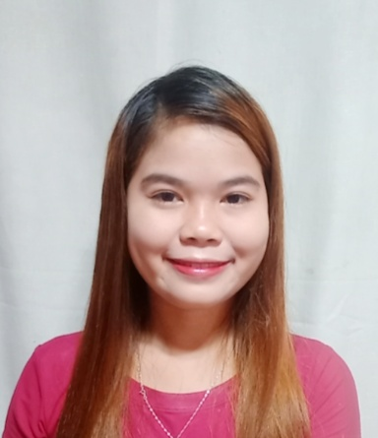
ELIZABETH F OÑEZ
Address: Purok 5 Silangan, Sta Cruz,New Corella,Davao del Norte
Contact Number: 09654353587
OBJECTIVE:
Looking for a career that will allow me to share my knowledge and skill and learn more in your company.

PERSONAL INFORMATION

Full Name : Elizabeth F Oñez
Date of Birth : July 2 1999
Birthplace : New Corella Davao del Norte
Sex : Female
Age : 22years old
Height : 5'6
Weight : 48kls.
Civil Status : Single
Religion : Roman Catholic
Nationality : Filipino
Father : Vergilio P. Oñez
Mother : Elsa F. Oñez

EDUCATIONAL ATTAINMENT

YEAR COURSE NAME OF SCHOOL/INSTITUTE

2017-2018 Senior High (GAS-GENERAL ACADEMIC STRAND) New Corella National High School

2011-2012 Elementary-Graduated Sta. Cruz Elementary School

WORK EXPERIENCE
13MONTHS- SALES ASSOCIATE GAISANO GRANDMALL TAGUM

CHARACTER REFERENCE
NAME POSITION/DESIGNATION ADDRESS
DANTE BOCTOTO PUNONG BARANGAY STA. CRUZ, NEW CORELLA, DDN
GILBERT BOCTOTO PRK. CHAIRMAN STA. CRUZ, NEW CORELLA, DDN

I HEREBY CERTIFY that the above information is through and correct to the best of my knowledge and believe.

Sincerely,

Elizabeth F. Oñez
Applicant

